The Examiner
MAY 28 2017 - 4:30PM
SmokeFree Tasmania and Minister trade barbs
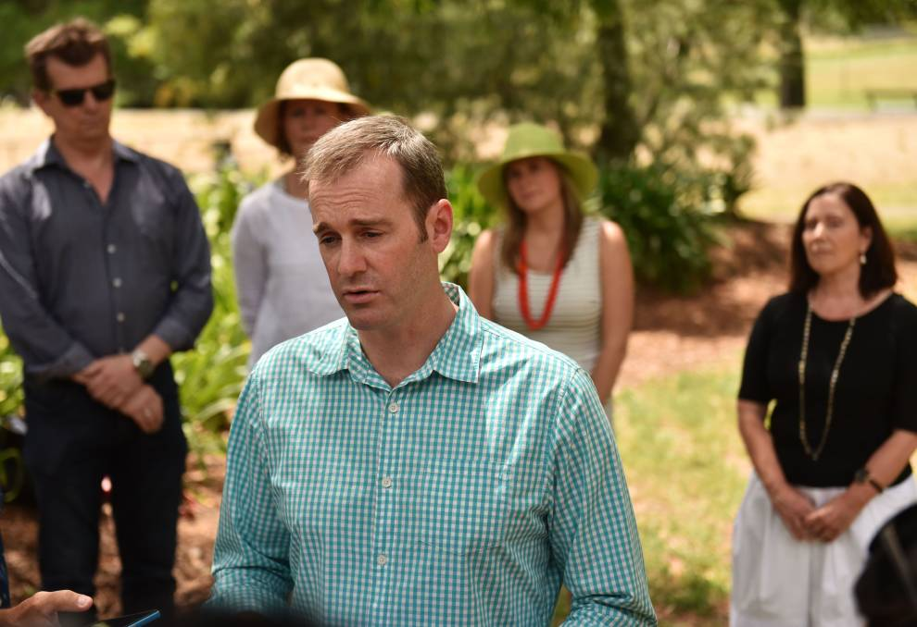
REJECT: Health Minister Michael Ferguson has slammed comments made by SmokeFree Tasmania about the government's relationship with tobacco companies.
A war of words has erupted between the Health Minister Michael Ferguson and advocacy group, SmokeFree Tasmania, after it accused the government of bowing to the wishes of big tobacco companies.
The stoush comes after Tasmania was named runner-up in the Australian Medical Association’s Dirty Ashtray Award – for governments that make the least effort to reduce smoking.
Responding to the second placing, Health Minister Michael Ferguson said the state would achieve better scores from the association as more policies aimed at reducing smoking rates were implemented.
But SmokeFree Tasmania north member Harley Stanton said the government had included suggestions from big tobacco companies to formulate its Healthy Tasmania Strategic Plan.
“Given that the Tasmanian government, in its healthy Tasmania policy, included advice from Imperial Tobacco it is not surprising that they have been nationally rebuked,” he said.
“This is both embarrassing internationally and bad conduct for any government.”
Fellow SmokeFree Tasmania adviser Kathryn Barnsley said the government needed to distance itself from tobacco companies.
She said the benefit of the government’s crusade on the illicit tobacco market benefited tobacco companies, like Imperial Tobacco.
“The tobacco industry wants the government to crack down on illicit tobacco, but the illicit market is not a health problem,” she said.
But Mr Ferguson slammed the comments as “complete and utter rubbish”.
“I also point out for the record that last year, the government proposed as part of the five-year plan raising the smoking age to 21, and SmokeFree Tasmania aggressively campaigned against it which is inexplicable,” he said.
Dr Barnsley said the government had also failed to provide more money for mass-media campaigns to reduce smoking rates.
Dr Stanton criticised the government’s health expenditure announced in last week’s budget.
“Prevention is better than a cure and reducing the number of people smoking will take pressure off our hospitals,” he said.

